**22.1. Advanced Mappings Overview**

**Hibernate advanced mapping**:

In our database we most likely will have

1. Multiple Tables
2. Relationships between Tables

Need to model this with Hibernate

**Types of advanced mapping in hibernate**:

There are three different type of mapping in hibernate

1. One-to-One
2. One-to-Many, Many-to-One
3. Many-to-Many

**1) One-to-One Mapping**:

One-to-one mappings represent simple pointer references between two Java objects. In Java, a single pointer stored in an attribute represents the mapping between the source and target objects. Relational database tables implement these mappings using foreign keys.

An instructor can have an “instructor detail” entity

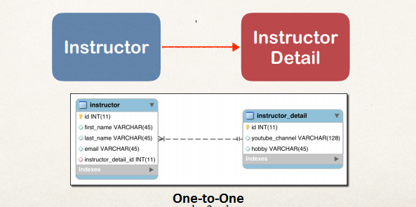

**2) One-to-Many**:

In simple terms, on-to-many mapping means that one row in a table can be mapped to multiple rows in another table. For example, think of an Instructor where we have another table for courses. An instructor can have multiple courses, so here we have one to many mapping.

An instructor can have many courses

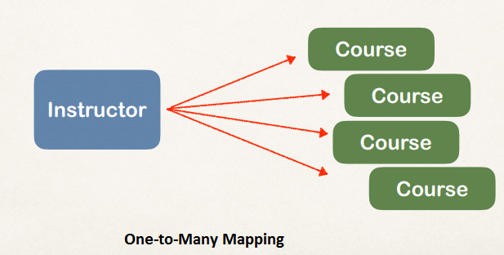

**3) Many-to-Many Mapping**:

Many-to-Many mapping is usually implemented in database using a Join Table. For example we can have student and course table for many-to-many mapping. Every student can have multiple courses and every course can be taken by multiple students, so we have a many-to-many mapping here.

* A course can have many students
* A student can have many courses

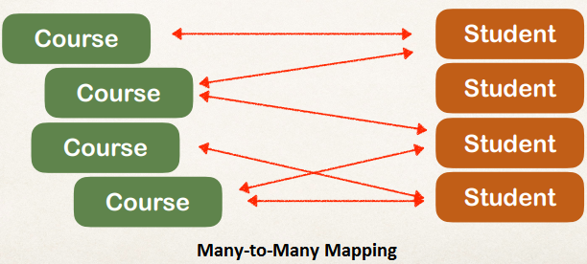

22.1. Advanced Mappings Overview